Java

|  |  |
| --- | --- |
| Java basics | Data Types, Variables, Operators, Control Statements, Loops, Arrays, Classes, Objects, |

Open labs

Then check for Java version

In cmd type

Java –version

 or

Java -v

17 installed

Plz check for any of the ide’s is installed

Eclipse

Or intellij

Or vs code

Variable

X, y, name, age,

int —> data type

int age;     ====> variable declaration

char name;

Assign value to a variable

age = 10;

name = ‘k’;

Declaring and assigning value to a variable

int age = 20;

char name =’M’;

Types of data types👍

Primitive

Int, char, float…

 and non primitive

String, array…

Methods:

Public ===> anyone can access…   ===> access modifiers in java (access specifiers in c++)

main ====> boss of your program   ===> entry and exit point of the program

static ===> fixed ===> retains its value..  Variables X Static

Void ===> return type ====> return 0 value  ===> success

Or

int add() {

int x =20;

return x;

}

public static void main(String[] args){

//body of the main

}

===============================

Try in c

================================

int add(){

int x = 10;

static int y = 20;

x++;

y++;

printf(“%d”, x);

printf(“%d”, y);

}

main(){

add();  ===>

add();

add();

}

—----$$$$$$$$$$$$$$$$$$------------------

#include <stdio.h>

int add()

{  int x=10;

static int y=20;

x++;

y++;

printf("%d\n",x);

printf("%d\n",y);

}

void main() {

add();

add();

add();

}

======================================================

Task 1:

Task001:

Wap to display greetings

Code:

public class Task001 {  
 public static void main(String[] args){  
  
 System.*out*.println("Hi how are you");  
 System.*out*.println("Learning Java");  
  
 }  
}

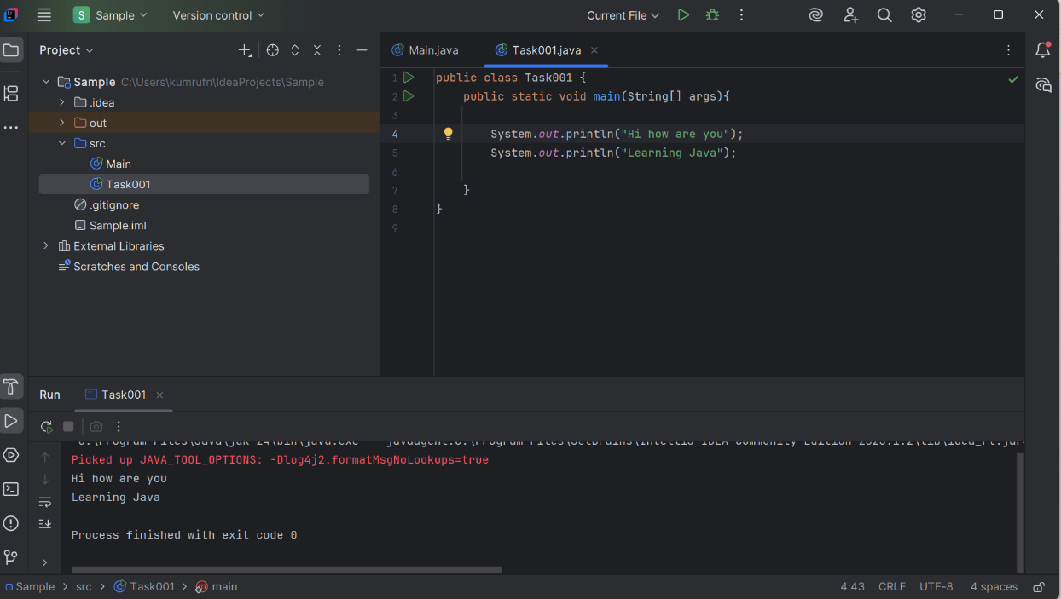

Task002:

Wap to create a add method and call the method 3 times ..

Hint in method add declare variables and display them

Code :

ublic class Task002 {  
  
 // Method to add two numbers and display the result  
 public static void add() {  
 int a = 5;  
 int b = 10;  
 int sum = a + b;  
 System.*out*.println("Sum: " + sum);  
 }  
  
 public static void main(String[] args) {  
 // Calling the add() method three times  
 *add*();  
 *add*();  
 *add*();  
 }

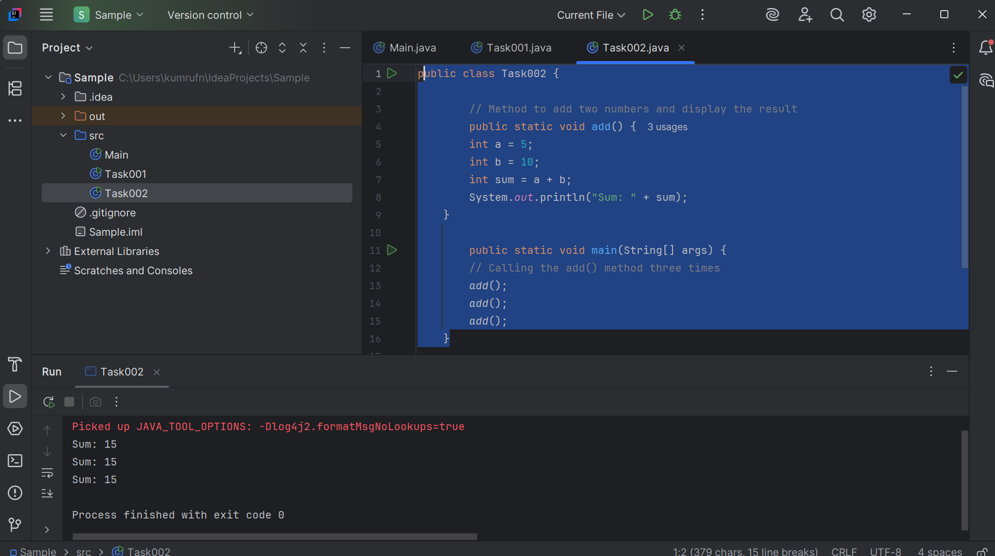

Task003

 Write a Program in Java to Add two Numbers.

Input: 2 3

Output: 5

public class Task003 {  
 public static void main(String[] args){  
 int num = 2;  
 int num1 = 3;  
 int sum = num + num1;  
 System.*out*.println("sum: " + sum);  
 }  
}

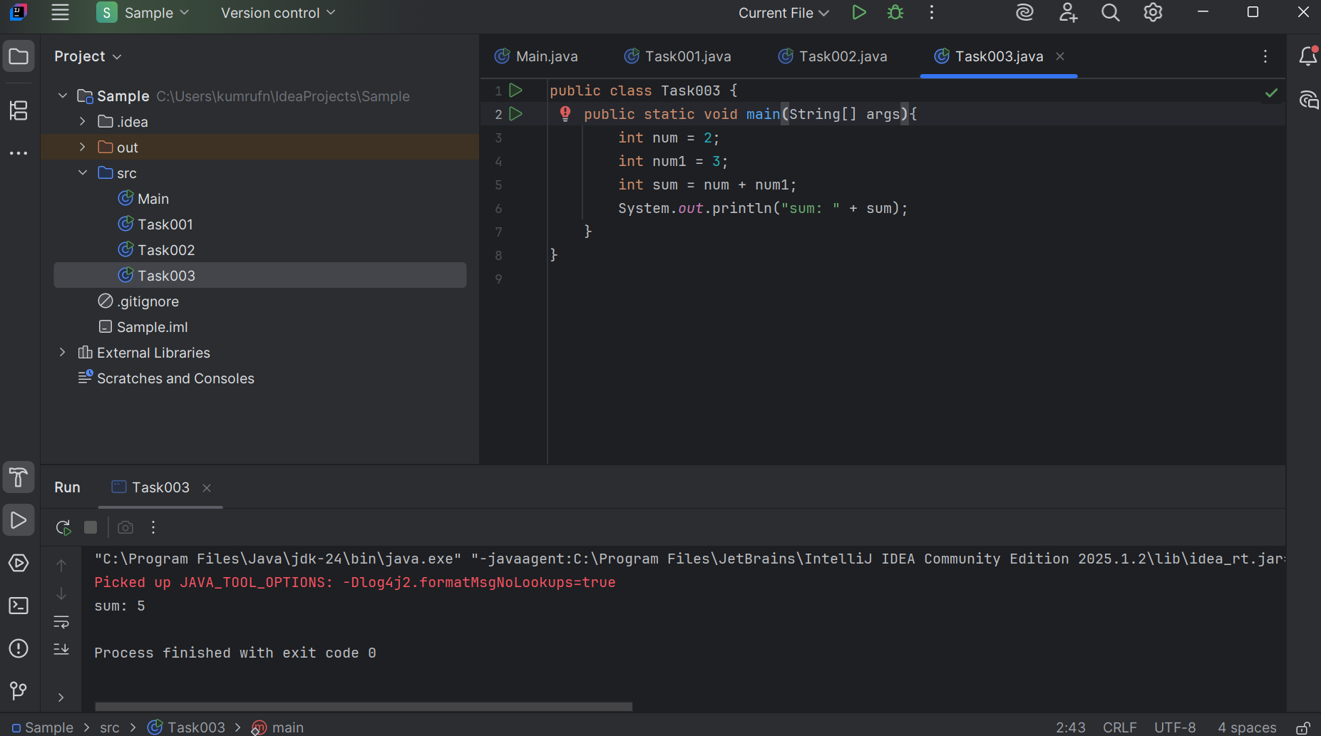

Task004

Write a Program to Swap Two Numbers

Input: a=2  b=5

Output: a=5  b=2

public class Task004 {  
 public static void main(String[] args){  
 int a =2;  
 int b =5;  
System.*out*.println("Before Swap: a = " + a + ", b = " + b);  
int temp =a;  
a =b;  
b =temp;  
System.*out*.println("After swapping: a = " + a + ", b = " + b);  
 }  
}

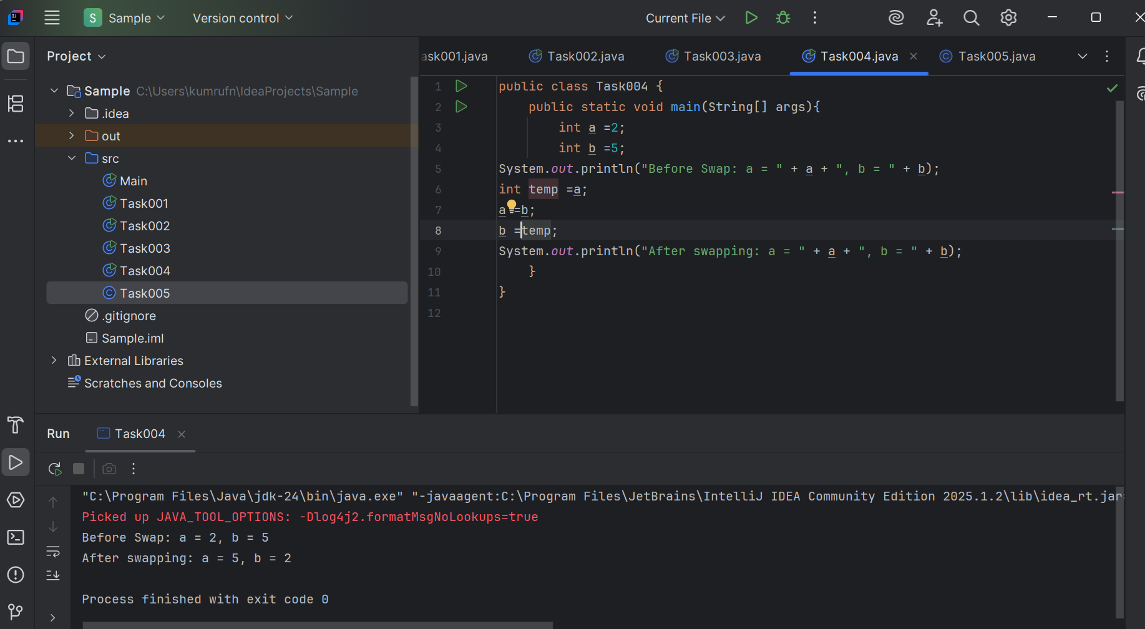

Task005

Create a code in which you have 4 methods add, subtract, multiply and divide (return type int) with a main [method..to](http://method..to) call all the other methods

Out put:

Main started

Sum of 2 numbers is …..

Diff of 2 numbers is —-

Product of 2 numbers ….

Division of 2 numbers is ….

Main ended

Task006

Write a program to check if a is greater or b.. Use ternary op

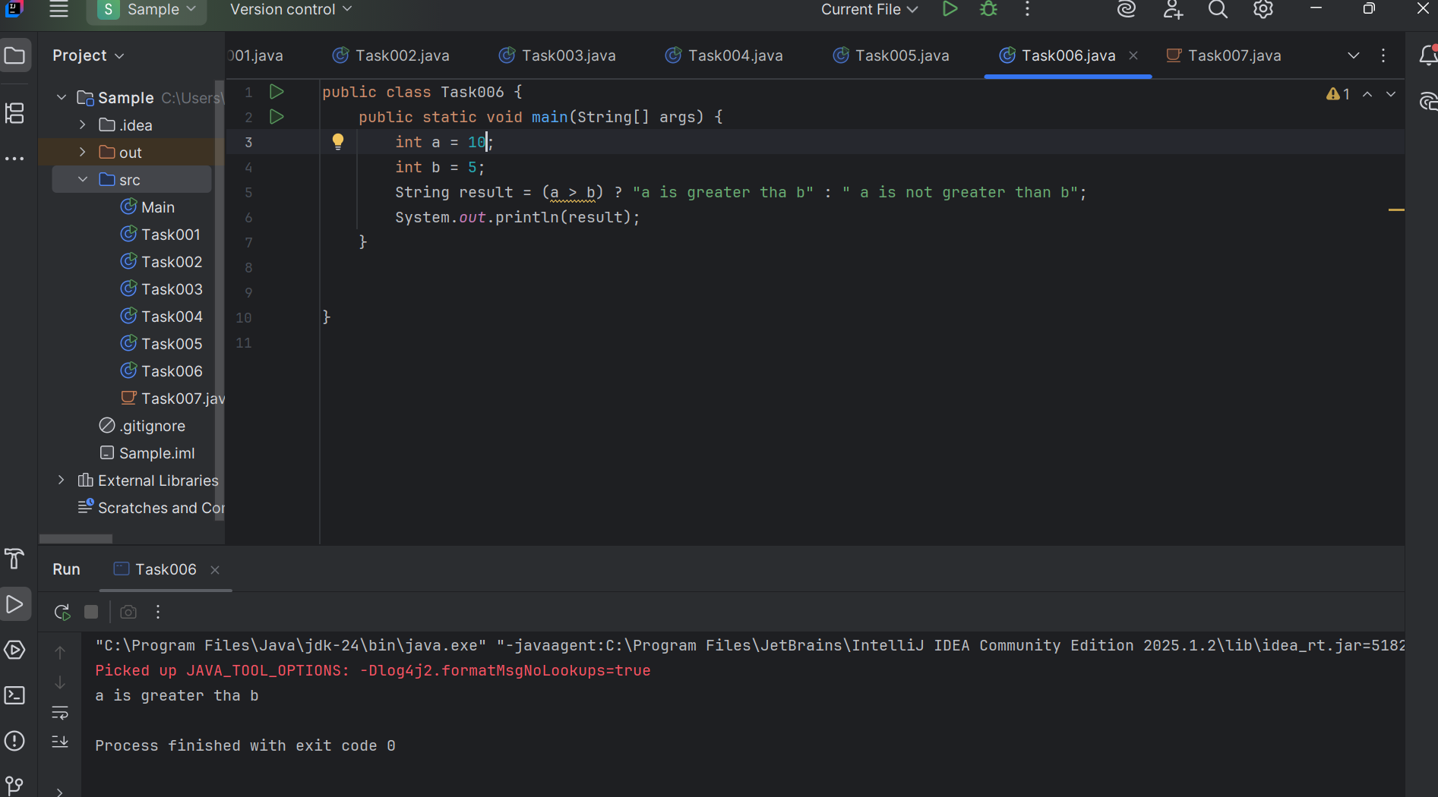

Task007

Write a program to take input from the user and display it to the user

Input:

Id : Prasunamba

Pwd: 123456789

Output:

Hi ,

Your login id is Prasunamba

And your pwd is *********

HInt :

For scanner … import java.util.scanner;

Scanner sc = new Scanner([System.in](http://system.in));

Id = sc.nexLine();

import java.util.Scanner;  
  
public class Task007 {  
 public static void main(String[] args) {  
 Scanner input = new Scanner(System.*in*);  
  
  
 System.*out*.print("Id: ");  
 String id = input.nextLine();  
  
 System.*out*.print("Pwd: ");  
 String pwd = input.nextLine();  
  
  
 System.*out*.println("You entered:");  
 System.*out*.println("Id: " + id);  
 System.*out*.println("Pwd: " + pwd);  
  
 input.close();  
 }  
}

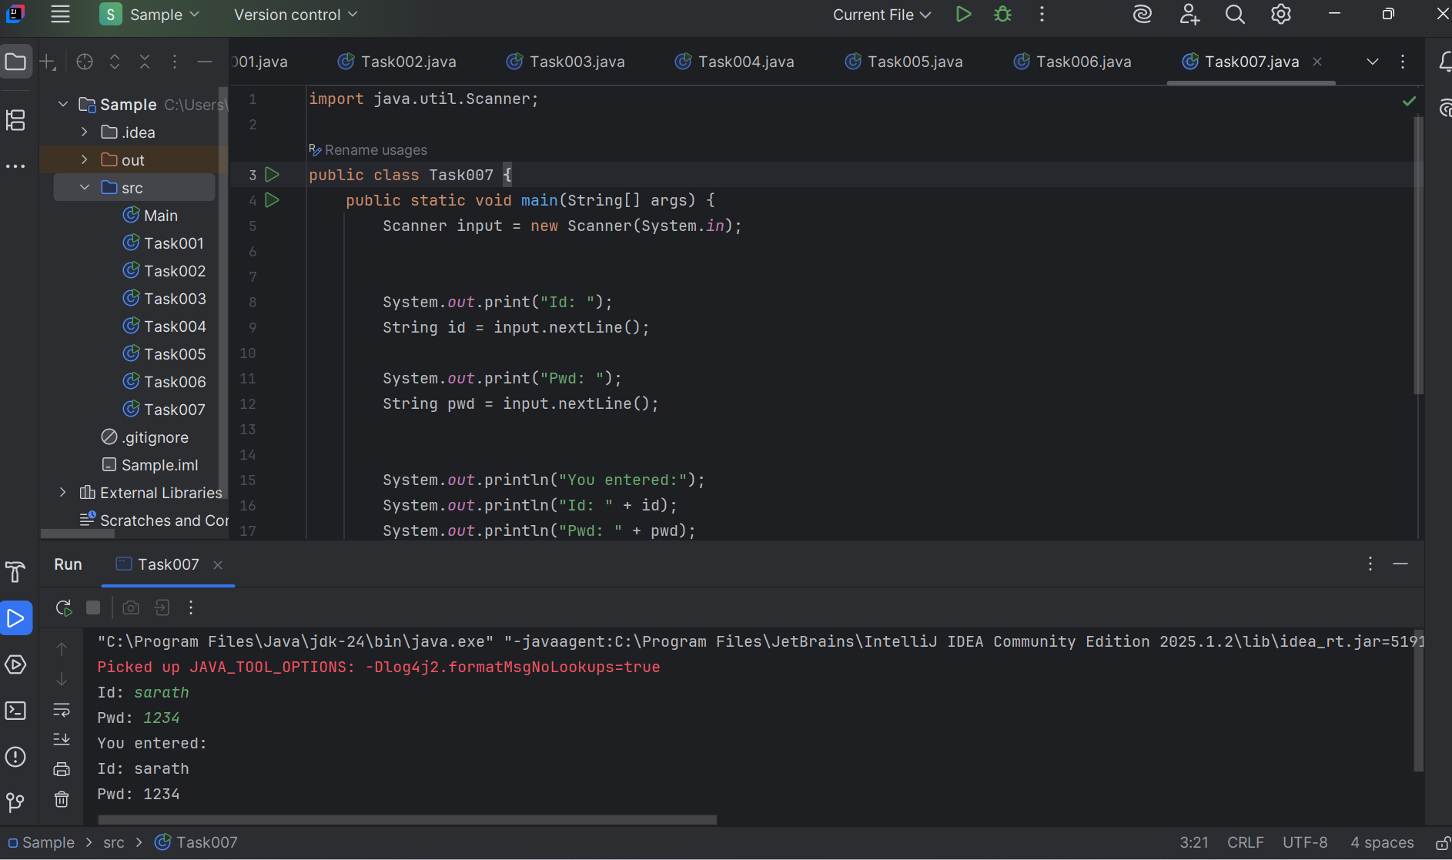

Task008

Write a program to create a class named Customer

Call the customer class in Task008 class using an object.

Hint

In the main method

Class Customer{

  void accept(){

sysout(“accept customer called”);

}

Void display(){

sysout(“display customer called”);

}

}

Public class Test008{

psvm(String[] args){

Customer cobj = new Customer();

cobj.accept();

cobj.display();

}

}

class customer {  
 void accept() {  
 System.*out*.println("accept customer");  
 }  
}  
public class Task008 {  
 public static void main(String[] args) {  
 customer custome = new customer();  
 custome.accept();  
 }  
}

or

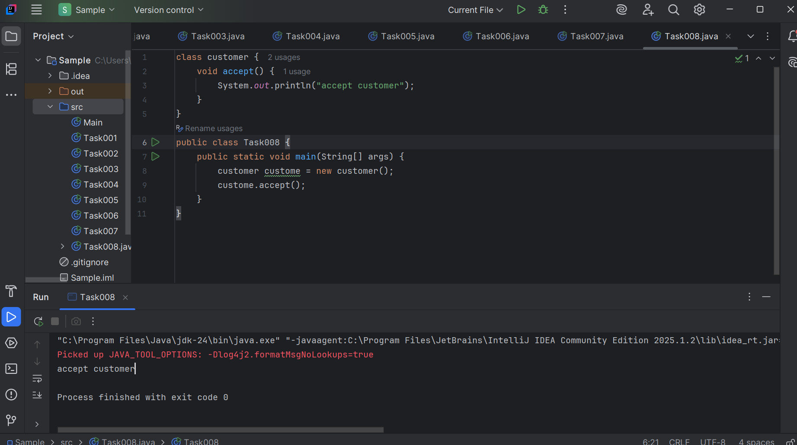

Task009:

Wap to check the greater of 2 numbers

Hint:

Use if else

If ( num1 > num2){

sout(“num1 is greater”);

}

Else {

sout(“num2 is greater”);

}

Code :

public class Task009 {  
 public static void main(String[] args) {  
 int a = 20;  
 int b = 20;  
  
 if (a > b) {  
 System.*out*.println(a + " is greater than " + b);  
 } else if (b > a) {  
 System.*out*.println(b + " is greater than " + a);  
 } else {  
 System.*out*.println("Both numbers are equal");  
 }  
 }  
}

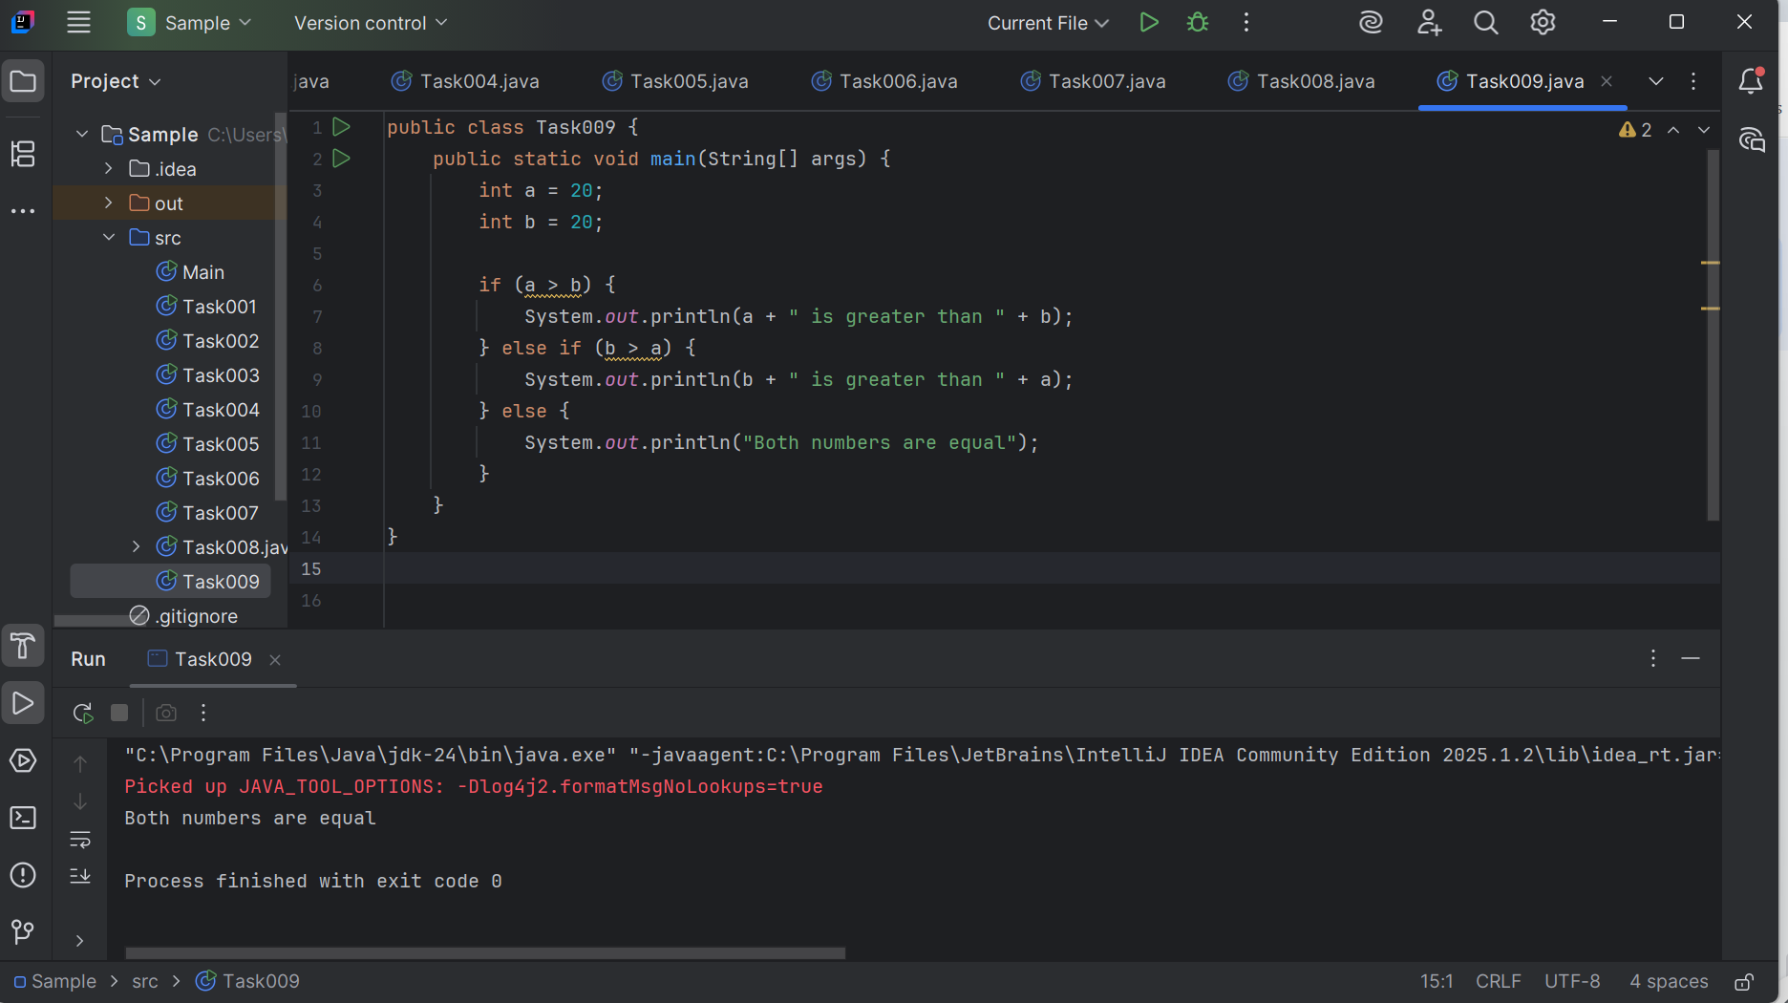

task 010

Wap to check greater of 3 numbers

Hint 👍

Use elseif

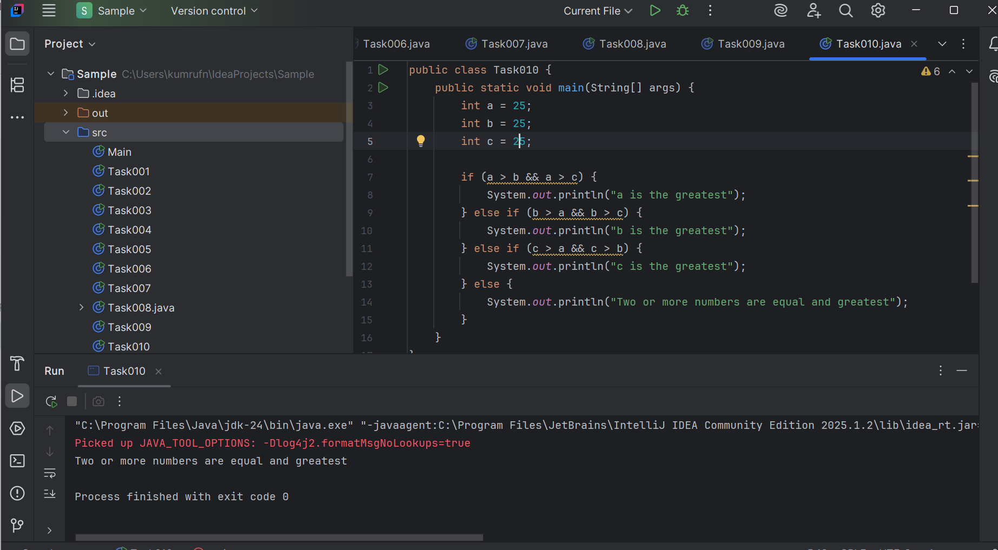

Task11:

Wap to check if  week days

1  ===> sunday

2 ===> monday

So on

8 and above ===> invalid input

Hint : use Switch case

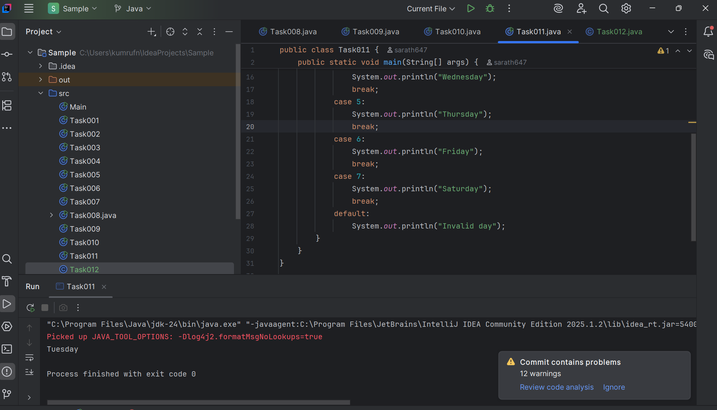

Task 012

Wap to check loginid and password validation

Hint use while loop

Scanner sc = new Scanner(System.in);

String loginid = “Prasunamba”

String pwd = “12345867”

Int Count = 0;

While (loginid == “Prasunamba” && pwd == “12345867”){

sout(“ you have logged in for  ”+ count++ +” times”);

sout(“enter ur login id and password”);

loginid = sc.NextLine();

pwd = sc.NextLine();

}

Do while also use 👍

Scanner sc = new Scanner(System.in);

String loginid = “Prasunamba”

String pwd = “12345867”

Int Count = 0;

do{

sout(“ you have logged in for  ”+ count++ +” times”);

sout(“enter ur login id and password”);

loginid = sc.NextLine();

pwd = sc.NextLine();

}While (loginid == “Prasunamba” && pwd == “12345867”);

sc.close();

While and do while loops - indefinite loops

For loop is definite…

For (initialization exp; condition exp; incre or decre exp)

Task 13:

Wap to display numbers from 10 to 1 .. skip 7 and 5.

for(int i= 10; i >0; i–){

If ( i == 5 || i == 7)

Continue;

sout(i);

}

Code :

public class Task013 {  
 public static void main(String[] args) {  
 for (int i = 10; i >= 1; i--) {  
 if (i == 7 || i ==5){  
 continue;  
 }  
 System.*out*.println(i);  
 }  
 }  
}

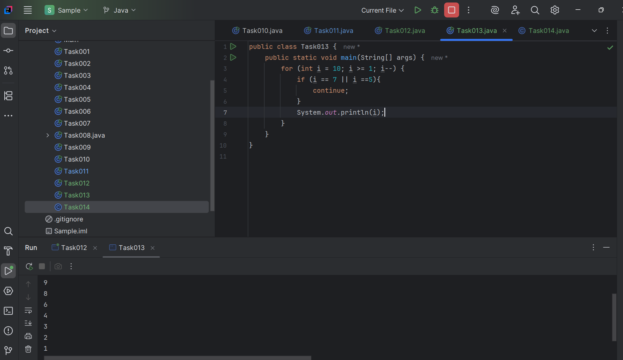

Task 014:

Arrays:

Try the below code and display the output…

Now play with it try to access arr of 5th index and see the output…and try to access arr of -1 index and see the output..

package Arrays;

public class Demo01 {

public static void main(String[] args) {

// TODO Auto-generated method stub

char[] arr = {'a','e','i','o','u'};

System.out.println(arr);

String[] names = {"Meena", "Tina", "Veena", "heena"};

System.out.println(names[0]);

names[1]= "Reena";

System.out.println(names[1]);

System.out.println(names.length);

System.out.println(names[4]);

//Exception in thread "main" java.lang.ArrayIndexOutOfBoundsException

}

}

Strings:

Code :

package Arrays;  
public class Task014 {  
 public static void main(String[] args) {  
 int[] arr = { 1, 2, 3, 4, 5};  
 System.*out*.println("Array elements:");  
 for (int i = 0; i < arr.length; i++) {  
 System.*out*.print("arr[" + i + "] = " + arr[i]);  
 }  
 System.*out*.println("\nAccessing arr[4]:");  
 System.*out*.println(arr[4]);  
 System.*out*.println("\nAccessing arr[-1]:");  
 System.*out*.println(arr[-1]);  
 }  
 }

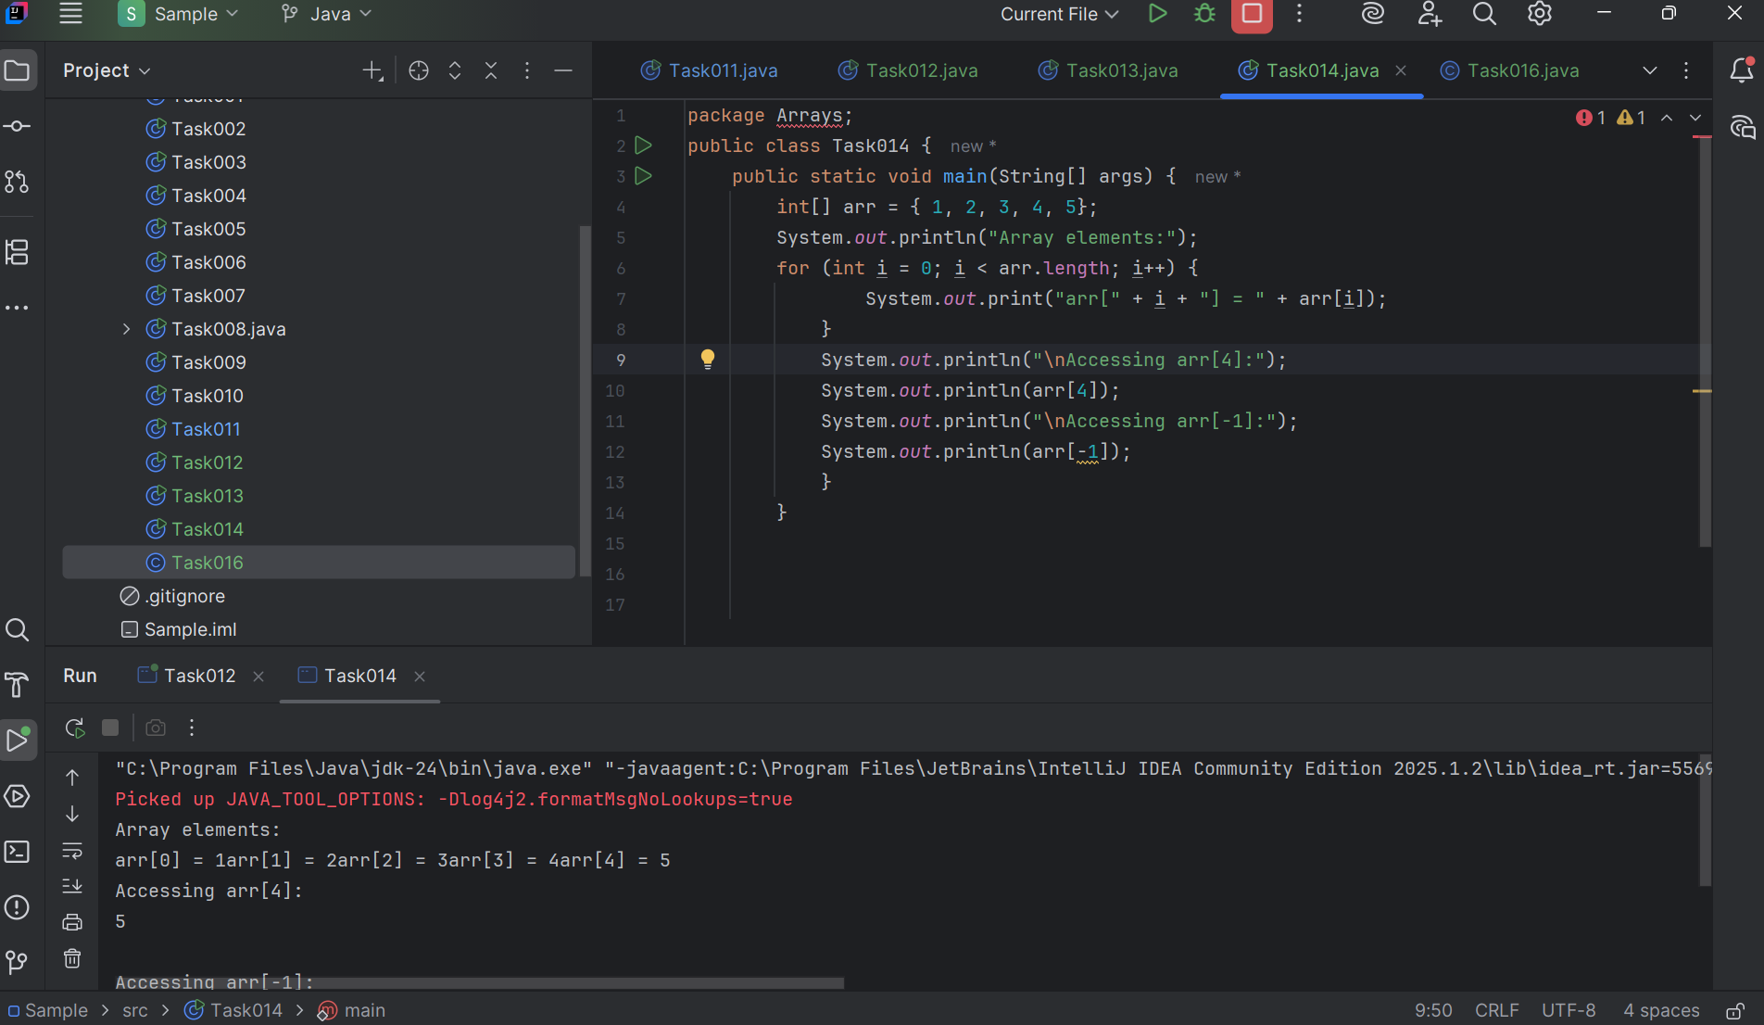

Task 015:

String – non primitive data gtype —> collection of characters or any value within “ ”

– immutable ⇒ cannot be changed

String Name = “Prasunamba is a trainer”;

Name = “Hello”;

Variables are mutable ⇒ which can be chaged

package StringHandling;

public class Demo01 {

public static void main(String[] args) {

// TODO Auto-generated method stub

String str1 = "Java Strings "; // string Literal

String str2 = new String(str1); // obj of the string - new keyword

String str3 = new String("are easy to learn ");

char ch[] = {'S', 't', 'r' ,'i', 'n', 'g'};

String str4 = new String(ch);

System.out.println(str1 + "\n" + str2 + "\n" +str3 + "\n" +str4);

}

}

Code :

public class Task015 {  
 public static void main(String[] args) {  
 String str1 = "bash ";  
 String str2 = new String(str1);  
 String str3 = new String("are easy to learn ");  
 char ch[] = {'J', 'a', 'v', 'a'};  
 String str4 = new String(ch);  
 System.*out*.println(str1 + "\n" + str2 + "\n" + str3 + "\n" + str4);  
 }  
}

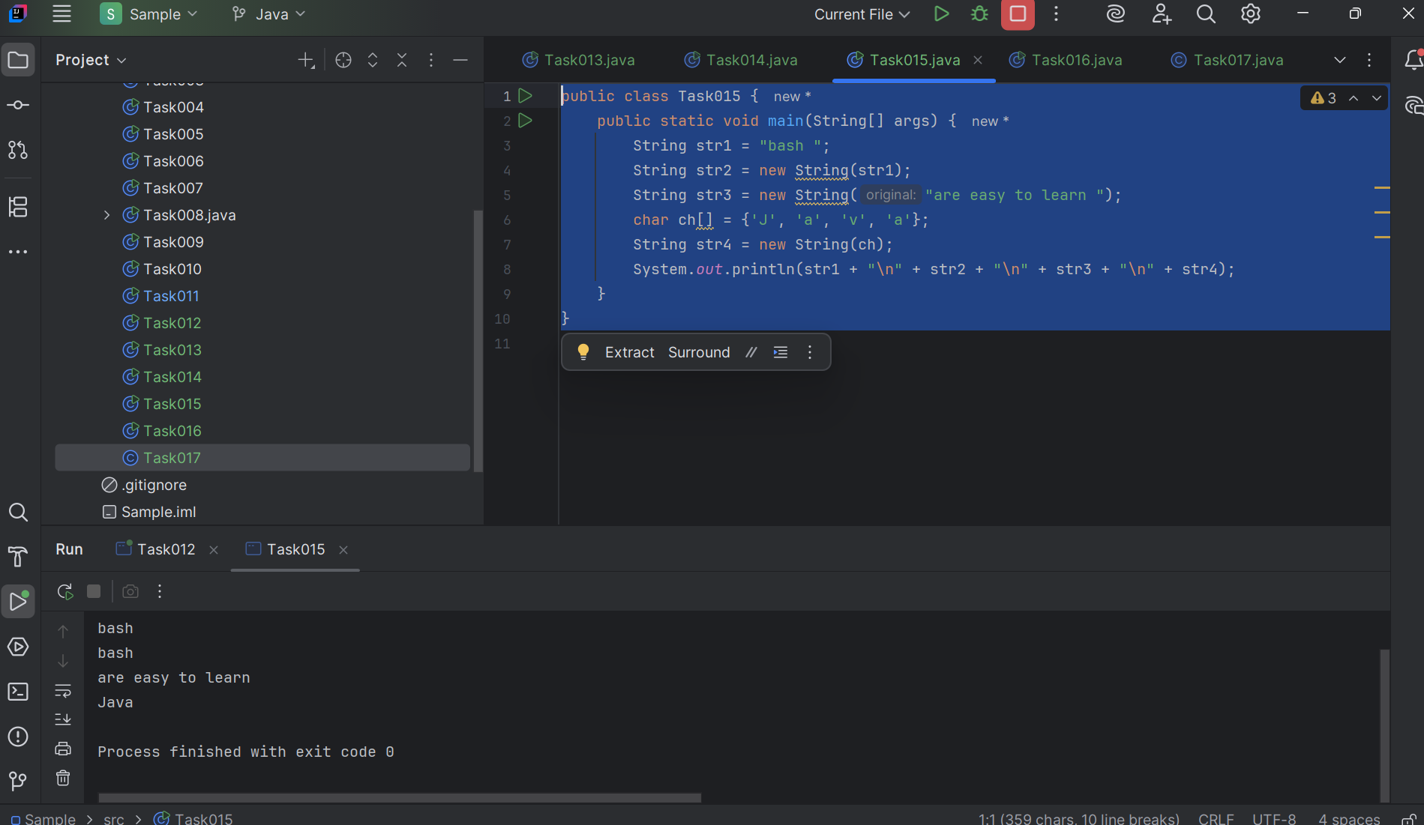

Task 016

Enums or Enumerations   – part of  collection framework

What is the output of the below code snippet

package Enumerations;

enum color{

red, blue, green, yellow

}

public class Demo01 {

public static void main(String[] args) {

color c1 = color.yellow;

System.out.println(c1);

}

}

package Enumerations;

enum Weekdays{

Sunday , Monday , Tuesday

}

public class Demo01 {

public static void main(String[] args) {

Weekdays c1 = Weekdays.Tuesday;

System.out.println(c1);

}

}

Code :

package Enumerations;  
  
enum color {  
 *Red*, *blue*, *green*}  
  
public class Task017 {  
 public static void main(String[] args) {  
 color c1 = color.*Red*;  
 System.*out*.println(c1);  
 }  
}

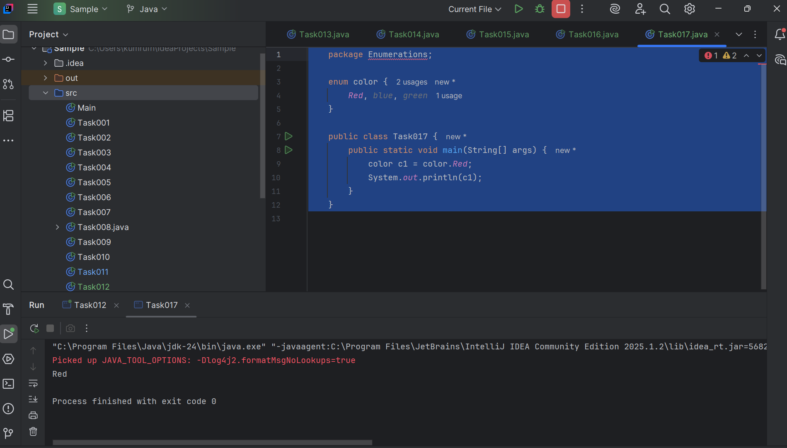

Task 017:

Getter and setter

Create a program name Person.java

public class Person {

   private String name;

   // Getter

   public String getName() {

     return name;

   }

   // Setter

   public void setName(String newName) {

     this.name = newName;

   }

}

Create another program named Task017.java

public class Task017{

  public static void main(String[] args) {

    Person myObj = new Person();

    myObj.name = "John";

    System.out.println(myObj.name);

  }

}

—----------------------------------what is the reason for the error —---------------explain

Code : public class Task017 {  
  
 public String name;  
 public void setName(String name) {  
 this.name = name;  
 }  
 public String getName() {  
 return name;  
 }  
 public static void main(String[] args) {  
 Task017 s = new Task017();  
 s.setName("Sarath");  
 System.*out*.println("Name: " + s.getName());  
 }  
}

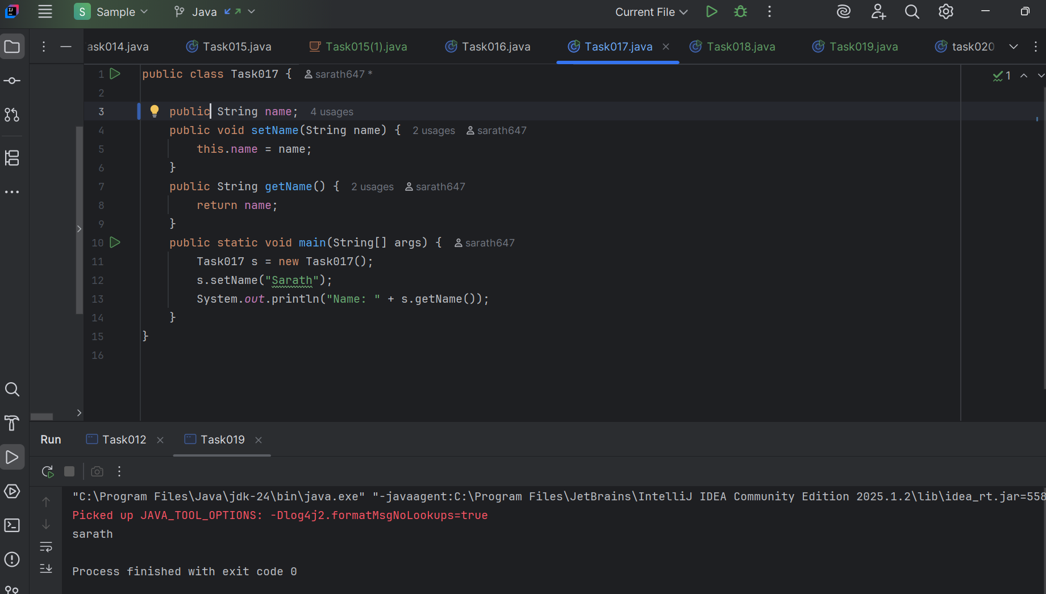

Task 18 :

Task 018

Now create one more program named Task018.java

public class Main {

  public static void main(String[] args) {

    Person myObj = new Person();

    myObj.setName("John");

    System.out.println(myObj.getName());

  }

}

Now —--------------think what is the output of the above code—--------------

=========================================================================================================================================================================

public class Task015{

    public static void main(String[] args){

        String Str1 = "Myname ";

        Str1 = "java";

        String str2 = "hello";

        System.out.println(Str1);

        System.out.println(str2);

    }

}

//string - immutable

//strings with the same content share storage ina single pool to minimize creating the copy of the same value again and again..

//a string is created/ generated , its content cannot be changed

// string are considered as classes -===> we create objects to it..

//cannot be changed one initialized in string

// variable =---> mutable

// age = 10;

// age = 11;

class Customer01{

    void accept(){

        System.out.println("Accept method");

    }

    void display(){

        System.out.println("display method");

    }

}

public class Task111{

    void method1(){

         System.out.println("method1 called");

    }

    static void static_method1(){

        // method1(); ==> cannot access as it is a non static member

         System.out.println(" static_method1 called");

    }

    public static void main(String[] args){

        Customer01 cobj = new Customer01();

        cobj.accept();

        cobj.display();

        static_method1();

        Task111 tobj = new Task111();

        tobj.method1();

        // method1();

    }

}

Code :

public class Task018 {  
 public static void main(String[] args) {  
 Task017 myObj = new Task017();  
 myObj.name = "Sarath";  
 System.*out*.println(myObj.name);  
 }  
}

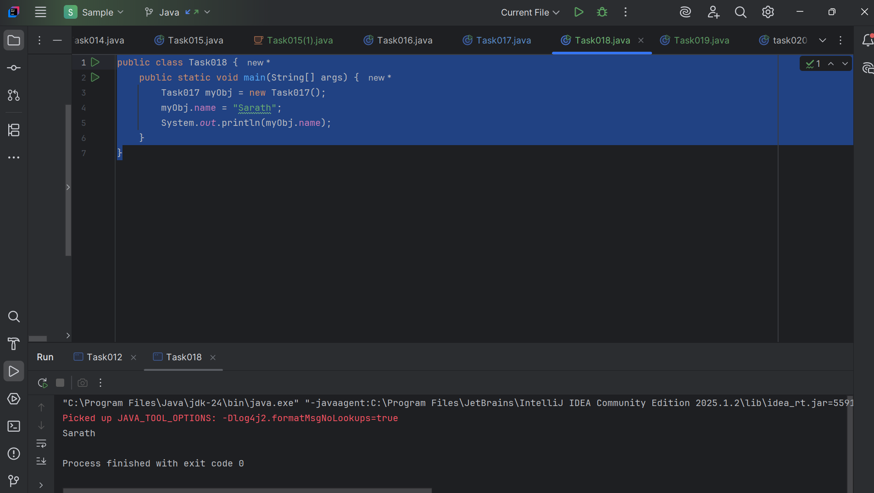

Task019.java

Wap to display the content of the above enum from the class Task016_1 in this program.. (main  needs to be added)

Arrays

Code :

public class Task019 {  
 public static void main(String[] args) {  
 Task017 myObj = new Task017();  
 myObj.setName("sarath");  
 System.*out*.println(myObj.getName());  
 }  
}

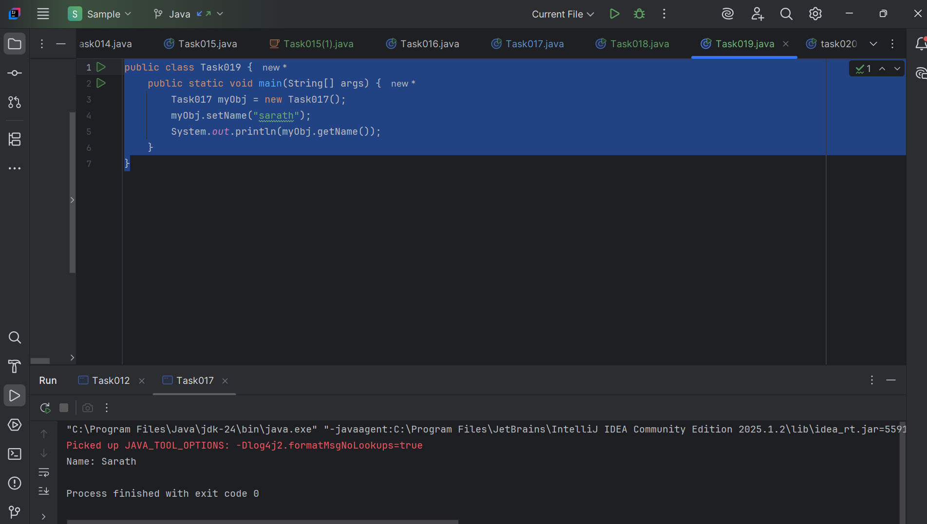

Task 020:

Create an array of your name

Hint : use

Char[] Name = {‘P’, “r’, ….}; // initializing an array

sout(Name);

Int n = Name.length; // size of your name

sout(“there are “+ n +”letters in my name”);

Use for loop to display each letter..

HInt: use ghe below code snippet…

// traversing array

        for (int i = 0; i < n; i++)

            System.out.print(Name[i] + " ");

sHALLOW copy and Deep copy

|  |  |  |
| --- | --- | --- |
| **Copy Type** | **Description** | **Example** |
| **Shallow Copy** | Both arrays share references to the same objects | **Shallow Copied Array :** [[obj1, obj2] , [obj3], [obj4]] |
| **Deep Copy** | New instances of objects are created. | **Deep copied array :** [[newObj1, newObj2] , [newObj3], [newObj4]] |

Code :

public class task018 {  
 public static void main(String[] args) {  
 // Initialize array with characters of the name  
 char[] Name = {'S', 'A', 'R', 'A', 'T', 'H'};  
  
 // Printing the array reference (not the contents)  
 System.*out*.println(Name); // This will print the name because char[] prints as string  
  
 int n = Name.length;  
 System.*out*.println("There are " + n + " letters in my name");  
  
 // Traversing array using for loop  
 for (int i = 0; i < n; i++) {  
 System.*out*.print(Name[i] + " ");  
 }  
 System.*out*.println(); // newline  
 // SHALLOW COPY  
 char[] shallowCopy = Name; // both arrays refer to the same object  
 shallowCopy[0] = 'X'; // modifying shallowCopy modifies Name too  
 System.*out*.print("After shallow copy change, Name: ");  
 for (int i = 0; i < n; i++) {  
 System.*out*.print(Name[i] + " ");  
 }  
 System.*out*.println();  
 // DEEP COPY  
 char[] deepCopy = new char[n];  
 for (int i = 0; i < n; i++) {  
 deepCopy[i] = Name[i];  
 }  
 deepCopy[0] = 'H'; // revert change only in deepCopy  
 System.*out*.print("Deep copy array: ");  
 for (int i = 0; i < n; i++) {  
 System.*out*.print(deepCopy[i] + " ");  
 }  
 System.*out*.println();  
 }  
}

